1. Write a program that defines a function count_lower_upper() that accepts a string and calculates the number of uppercase and lowercase alphabets in it. It should return these values as a dictionary. Call this function for some sample strings.

def count_lower_upper(input_string):

lower_count = sum(1 for char in input_string if char.islower())

upper_count = sum(1 for char in input_string if char.isupper())

return {"Lowercase": lower_count, "Uppercase": upper_count}

# Example usage:

sample_string = "Hello World"

result = count_lower_upper(sample_string)

print(result)  
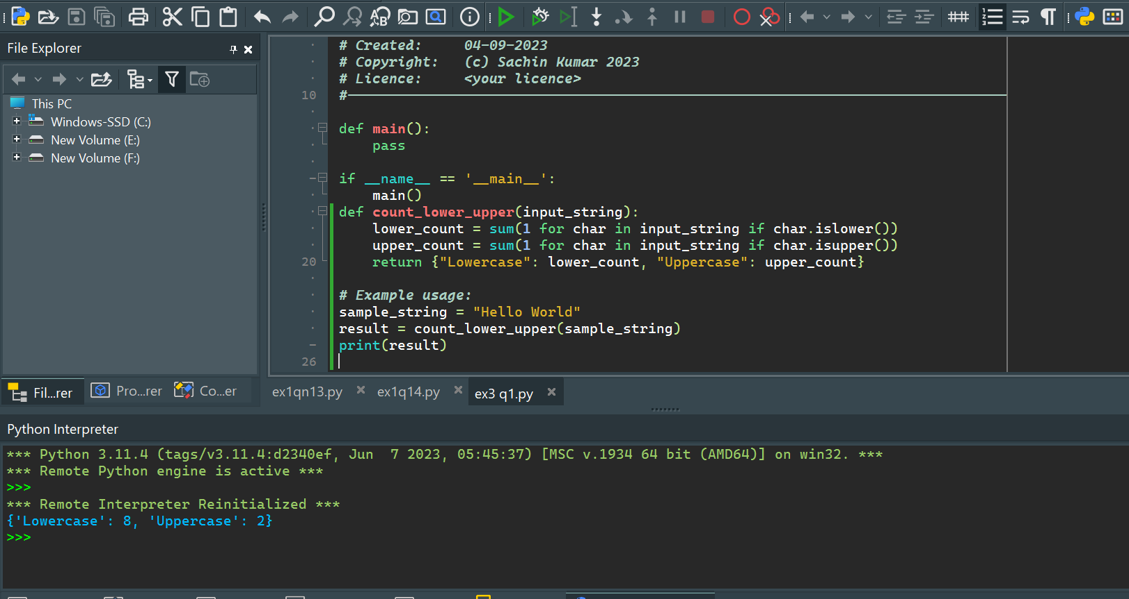

1. Write a program that defines a function compute() that calculates the value of n + nn + nnn + nnnn, where n is digit received by the function. Test the function for digits 4 and 7.

def compute(n):

return n + int(str(n) * 2) + int(str(n) * 3) + int(str(n) * 4)

# Test the function for digits 4 and 7

digit1 = 4

digit2 = 7

result1 = compute(digit1)

result2 = compute(digit2)

print(f"For digit {digit1}, the result is: {result1}")

print(f"For digit {digit2}, the result is: {result2}")

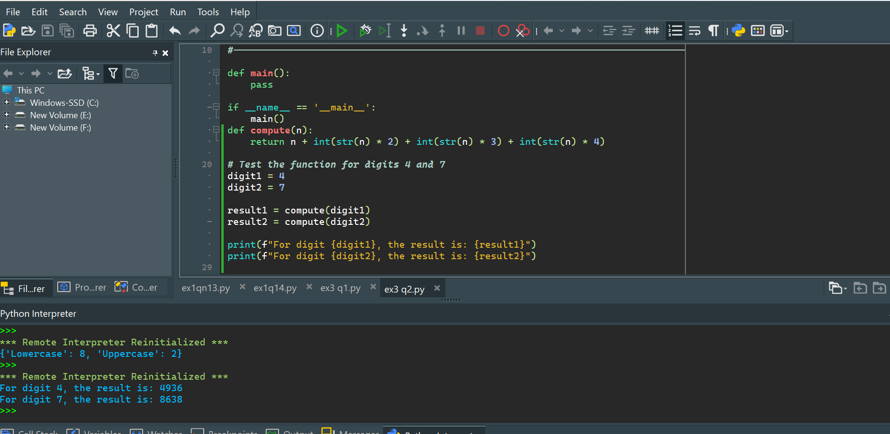

1. Write a program that defines a function create_array() to create and return a 3D array whose dimensions are passed to the function. Also initialize each element of this array to a value passed to the function.

def create_array(x, y, z, initial_value):

# Create a 3D array filled with the initial value

arr = [[[initial_value for _ in range(z)] for _ in range(y)] for _ in range(x)]

return arr

# Example usage:

x_dim = 3

y_dim = 4

z_dim = 2

initial_value = 0

result_array = create_array(x_dim, y_dim, z_dim, initial_value)

# Print the resulting 3D array

for x in result_array:

for y in x:

print(y)

print()

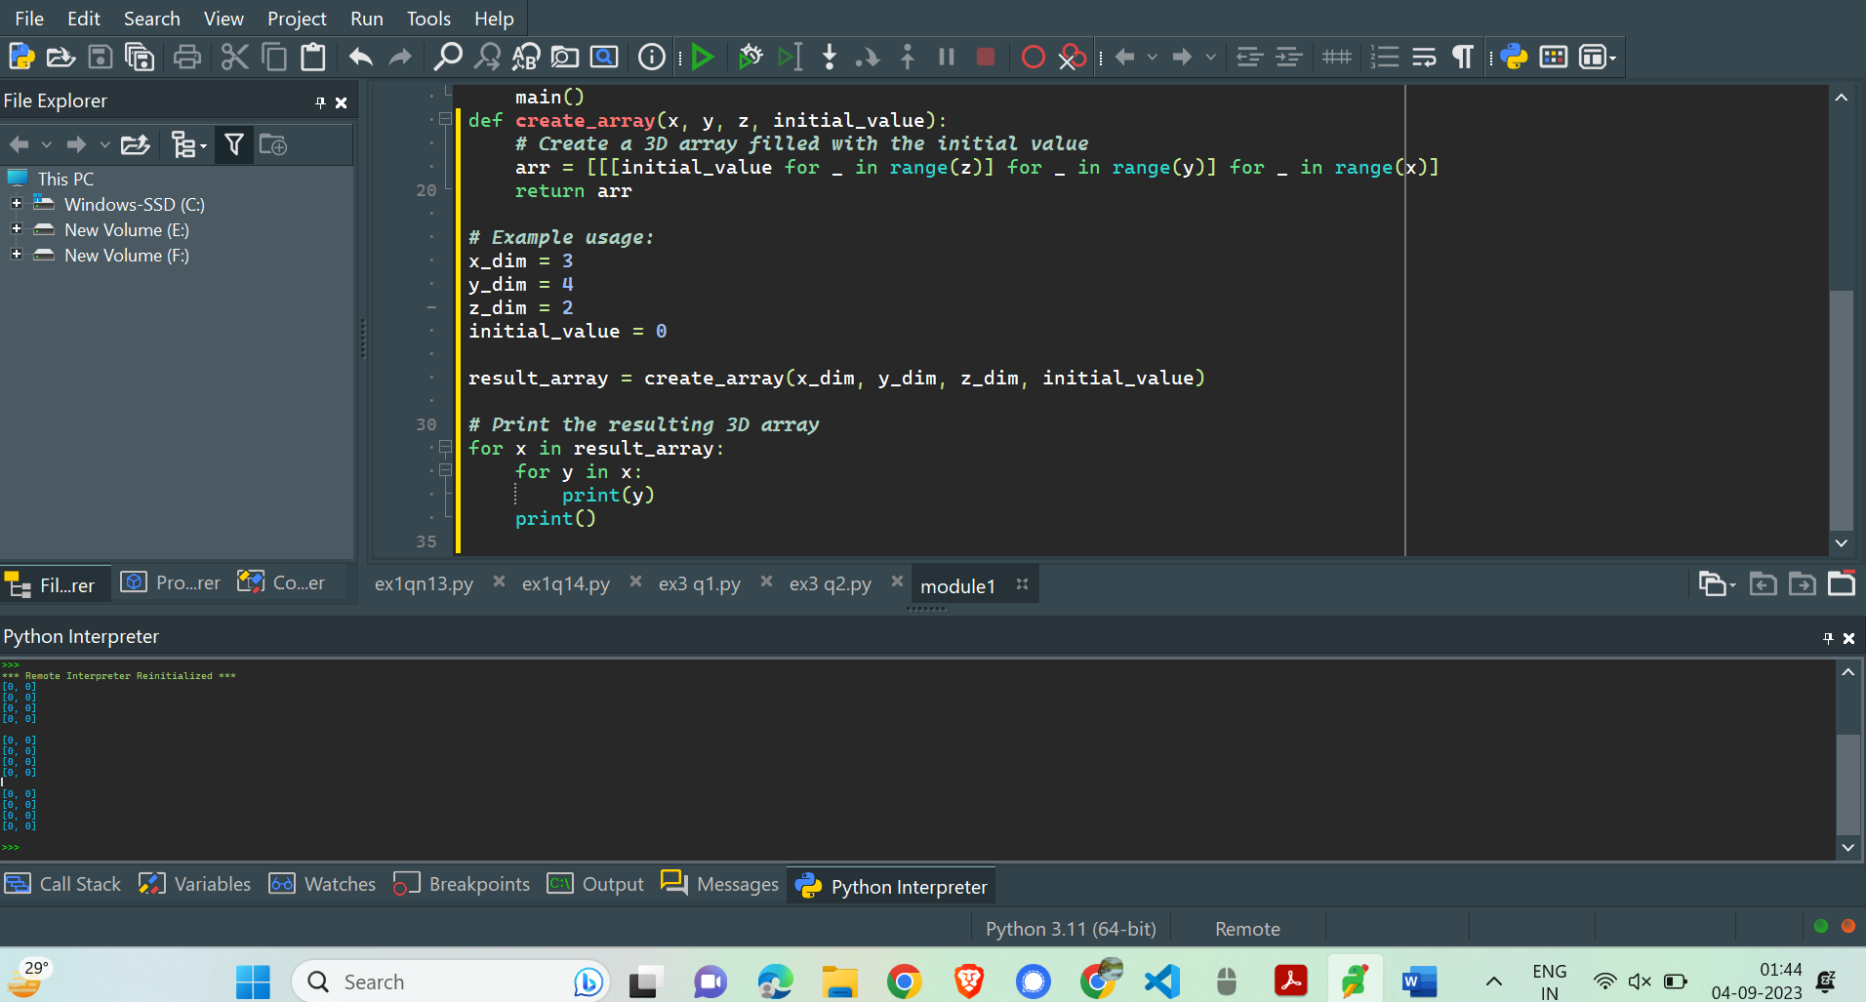

1. Write a program that defines a function create_list() to create and return a list which is an intersection of two lists passed to it.

def create_list(list1, list2):

# Use set intersection to find the common elements

intersection = list(set(list1) & set(list2))

return intersection

# Example usage:

list1 = [1, 2, 3, 4, 5]

list2 = [3, 4, 5, 6, 7]

result_list = create_list(list1, list2)

print("Intersection of list1 and list2:", result_list)

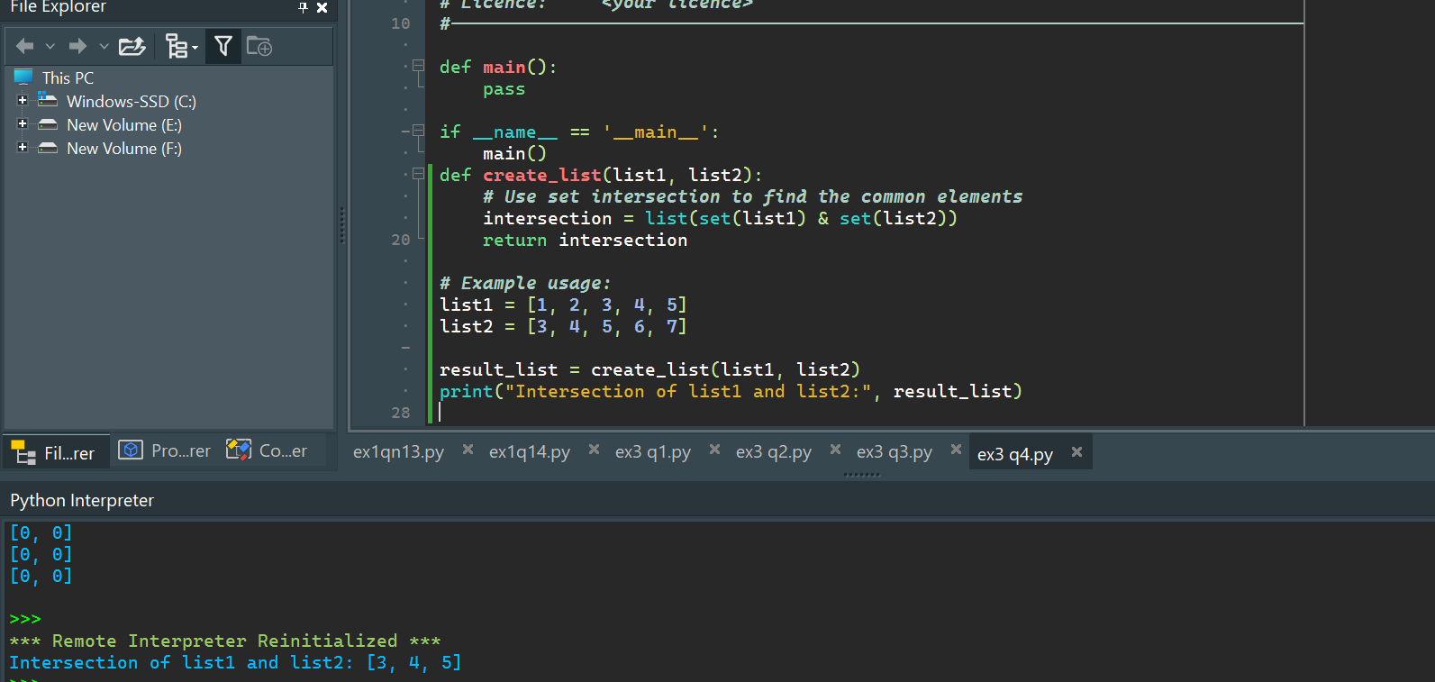

1. Write a program that defines a function sanitize_list() to remove all duplicate entries from the list that it receives.

def sanitize_list(input_list):

# Use set to remove duplicates, then convert back to list

sanitized_list = list(set(input_list))

return sanitized_list

# Example usage:

original_list = [1, 2, 2, 3, 4, 4, 5]

sanitized_result = sanitize_list(original_list)

print("Original List:", original_list)

print("Sanitized List (No Duplicates):", sanitized_result)

